Table of Contents

- SCOPE
- APPLICABLE DOCUMENTS
- INTRODUCTION
- TEST EQUIPMENT
- TEST SPECIMEN PREPARATION
- METHOD OF TEST

SCOPE
This specification describes the procedure for qualitative analysis of thermal spray coatings through bend test. This specification defines the acceptance criterion for qualifying the coating before spraying on the actual component.
Note: This document doesn’t advice on the safety norms to be followed. The user has to exercise necessary care while executing jobs as per this standard.
Note: Quality assurance tests for equipment’s as well as for personnel for executing Jobs as per this standard don’t fall under the preview of this standard.

APPLICABLE DOCUMENTS
There are no applicable documents for this specification.

INTRODUCTION
  - Bend test is a simple mechanical qualitative test for determining the spallation resistance of the thermal sprayed coating.
  - This is also a suitability test intended to check whether the settings of the equipment, surface preparation and spray parameters will permit the coating to bend properly before spraying on the part.

TEST EQUIPMENT
  - Equipment
The use of specific equipment is not required for this test. Equipment of local manufacture is recommended. It may be hand operated or automated. It must consist of a cylindrical bar having a 25 mm (1 inch) diameter and permit the test specimen to be positioned with accuracy and consistency. It must also permit the test specimen to bend 180° over the cylindrical bar. For bending the test specimen using the cylinder bar, a die as shown indicatively in figure.1 can be used.

  - Test Specimens
Rectangular panels having the following dimensions.
    - For all alloys except Titanium alloys: 25 x 100 x 1.5 mm minimum (1 x 4 x
0.06 inch).
    - For Titanium alloys: Use any stainless steel samples of above sample dimensions.

TEST SPECIMEN PREPARATION
  - Surface preparation of Test Specimens
Surface preparation of test specimens must be identical to that indicated for the part to be sprayed.
  - Spraying the coating
The test specimens must be coated under the same conditions as the part to be repaired. Unless otherwise specified, thickness of the coating should be as follows
- For single coat: 0.10-0.18 mm
- For double coat: Bond Coat: 0.07 ± 0.01 mm
Top Coat: 0.11 ± 0.01 mm

METHOD OF TEST
- Before the bend test, visually examine the coating for proper appearance, using 40 power magnifications. The coating must be free from cracks, voids, deficiency or other surface defects.
- Bend the test specimen over 180° with the uncoated side contacting the cylindrical bar.

- The test specimen subjected to the bend test is examined and evaluated according to the acceptance standard shown in figure 2. The coating must follow the distortion of the base metal. Cracks are acceptable within the bend area, with no evidence of peeling or flaking.
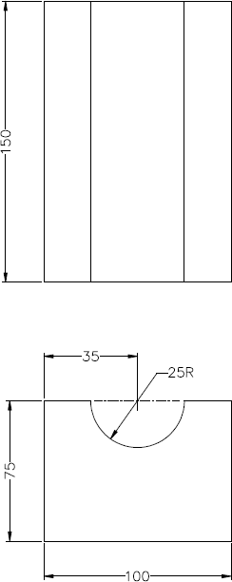
27R

Figure 1: Die for Coating Bend Test Specimen

Acceptance Standard for Bend Test Specimen

Areas of Areas of
Inspection Inspection

Good Acceptable limit

(Cracked without peeling)


Areas of Inspection

Unacceptable (Coating Spalling / Lifting)

Figure 2: Indicative pictures of coating acceptability for Bend testing

